# Business Process Modeling (ZimWays Product Delivery System)

### **1. Definition:**

This business process models the **product order and delivery flow** for the ZimWays platform — an online marketplace operating in Zimbabwe. The system allows buyers to order products from vendors, who then prepare the items and hand them off to delivery drivers for final delivery.  
**Objective:** Streamline the entire process from product selection to final delivery using an MIS-supported platform.  
**Expected outcomes:**

* Accurate and fast order handling
* Real-time communication between system actors
* Reduced order rejection and fraud
* Data collection for improved decision-making

### **2. Entities & Their roles**

| **Entity** | **Role and Interaction** |
| --- | --- |
| **Buyer** | Initiates product orders and confirms deliveries. Interacts with the system via frontend. |
| **Vendor** | Receives orders, checks stock, and prepares products. Responds with confirmation or rejection. |
| **System (MIS)** | Central automation hub. Handles order processing, notifications, status updates, and tracking. |
| **Delivery Driver** | Picks up products from vendors and delivers them to buyers. Marks orders as completed. |
| **Database** | Stores product info, user details, order status, and delivery logs. Enables analytics and MIS functions. |

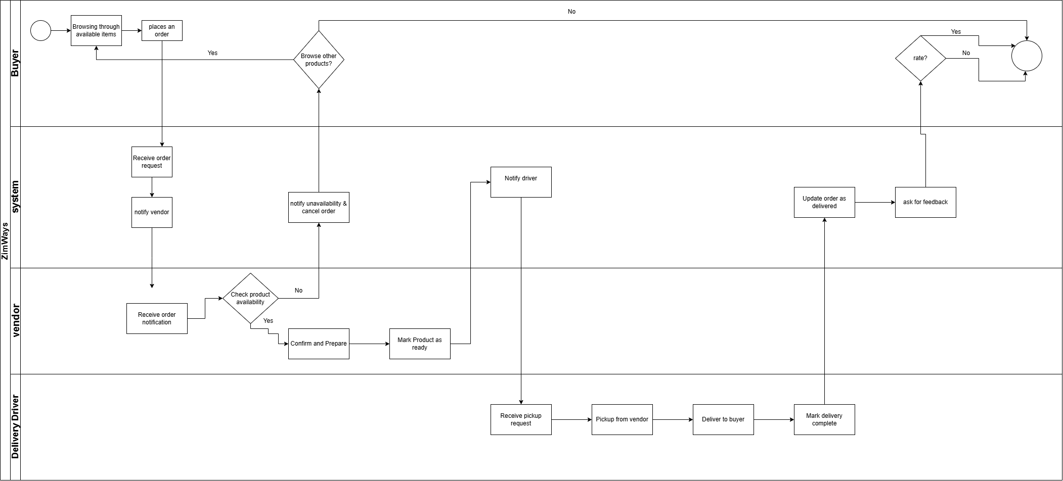

## 3. Explanation:

The diagram represents the full product order and delivery process for the ZimWays platform. It starts with the buyer selecting a product and ends when the product is delivered and confirmed. The system handles the orchestration between buyers, vendors, and delivery drivers. Vendors can accept or reject orders, and if accepted, they prepare the product for pickup. The system assigns a delivery driver, who completes the delivery and updates the order status. MIS plays a critical role in real-time updates, order tracking, and data storage, supporting better decision-making and operational efficiency across all actors. This process ensures a reliable and scalable product delivery workflow aligned with modern e-commerce needs.